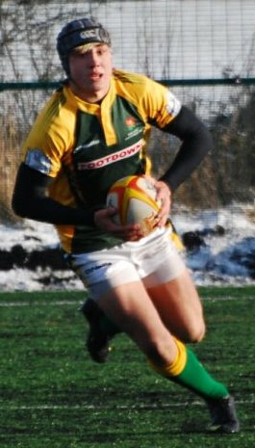
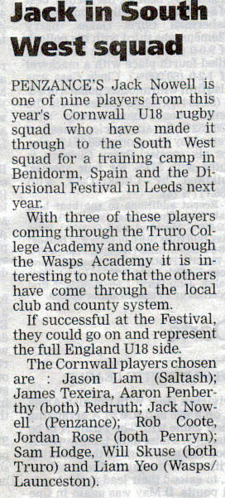

Jack Nowell
24 North Corner
Newlyn, Penzance
Cornwall
TR18 5JG
01736 366743
jtnowell@hotmail.co.uk

January 2010

Dear Mr & Mrs Williams,

My name is Jack Nowell, I am 16 years of age. I attended Newlyn and Mounts Bay Schools and now attend Truro College and play for their Rugby Academy 1st team.

Rugby has been my life since I began my career for Penzance Pirates U6 at the Menaye Field in 1998 and I am still playing for the Colts.

I have represented Cornwall playing for U15, U16, U17 and U18.
I was selected to play for Cornwall U18 a year early and during one match was spotted and selected to play for South West of England.
With the South West team I recently travelled to Spain for a warm weather training week and played against the Spanish U18 team.
On New Years Day I travelled to Leeds for 4 days of matches against Midlands, North East and London areas, playing my position of Full Back in front of the England U18 selectors.

I was invited by Exeter Chiefs to attend their academy; throughout the summer of 2009 I travelled weekly from Penzance to Exeter to train. I have played for their U18 academy team at Sandy Park, the most notable matches against Leicester Tigers and South Africa in Sept 2009.

I now have the opportunity to tour South Africa with Truro Academy in March 2010, shortly followed by a tournament taking place in Tokyo, Japan.
I work at Newlyn Meadery and Chynance, Sheltered Housing for the Elderly at weekends and evenings to save towards my escalating costs and my parents & family help and support me all they can.

I am currently looking for financial sponsors to help me with my travelling and equipment expenses.
If you could see fit to make any contribution I would be very grateful.
Any monies would be payable to ‘Truro College’ and would be deposited in my Sponsor Account.
I can offer in return your company badge or logo printed on my personal kit and my expectation for the future is that I will have a lucrative career in rugby and will remember those who helped me on my way.
There is also an opportunity for you to promote your business in our ‘RugbyTour’ brochures.

Your contribution would enable me to further my vocation and take every opportunity offered to me.
Please contact me if you need more information.

Thank you in advance for your consideration and support.

Yours sincerely

Jack Nowell

